Felipe Wayszceyk – Assessment Module – Web Design

My website is designed to share my experiences living abroad, more specifically in Ireland. For the moment I do not have as many content as I would like yet, but my intention is improving the website site as I’m learning in the course, and posting more contents. What the positives and negatives sides, what you must be prepared to, I’ve include about my short part of my life, as why I chose Ireland. Also show what I’m learning and developing in this module, using the tools, and writing a clean and accessible code, being a mobile first.
Why the color choices, the color orange I got to make some reference with my hair, as when they see the website they can associate with me. Blue is to make reference about the sea and sky, to the top I chose dark blue because has more contrast with the orange. And make the people look first to there. And light blue to the main content to be easier to read. Because if I use a very strong color on there people will get tired when they read content
All the pages will have the header with the logo on the left side, when click on the logo it’s directed to the main page” Home”. Also, all pages will have a Navbar with the link on the right side, where will be possible to navigate to other pages, that will also work using “tab” on the keyboard making the website accessible.
About the Main page is Home, where I would like to show a short text about what the people will find in my website, this is the main. I will describe what I will be talking about in this website, a very small brief about me as well. It will have a sidebar, that idea is showing what I’m talking in the main content but in a few cards, that helps the people to get the main ideas.
When they go to page about, they will find my Story, about my dreams, when I started think to move abroad, why I chose Ireland for the first time and after again. My idea here in this page is make the people understand Who is Felipe, and what makes me chose Ireland. Also they understand the reasons I decided to live abroad, even this is not easy choice to anyone. The sidebar for this page is some very shorts parts about my story, here again. I thought in something that helps people to understand about the main text. I think in the future as I will growing and improving this website make this sidebar with the main, to send to the contents on there. My choice about using cards is to make people ready that, because many time sidebar get hidden in the websites.
Why Ireland, this page is to make the people thinking about why to choose some place and to show them is not as easy as we think it is. There are too many things to keep in consideration. I show them the positives point but also the negative ones. Everything is about my own experience, and the idea is helping the people make a good choice and right decision. For this side bar I thought something a bit different, with some tips. Because I think is very important and helpful when we get tips from someone who already passed through.
The last page is the page contact, to someone who wants any information, any help, my idea for the future is to some digital product. So this contact page will be very important. I will not put any other thing on this page to people be focus on the contact form.
Also in the footer there is a e-mail link that people can use.

I used the Html, css, bootstrap5, github and vs code in this project. I started building from zero, that was very challenging, mostly because I changed my mind in the middle of the project, to make this project I will be improving. I’ve used a lot of AI since from started, as it helped me to make the structure to build the idea I was thinking about, what I should to do first and how I could developer my idea. I will provide the screenshots below. When I was coding, I had many challenges and AI also helped in that. A lot of time I was trying to do something different and broke the code, but in some stages, I couldn’t find by myself what I did wrong. So I was putting the small part of the code to help to check what part I did wrong. For example, when I was creating the card for the sides bars I was couldn’t them as I wanted in the sidebar. Even I was looking back the contents we learned in this module, sometimes was almost impossible to figured out the reason the things were not working as my expectations. As I’m not a native speaker AI helped also with the translations, because in a lot of parts I would like to refer in a way but I didn’t have the exactly vocabulary for that. My github is no good as I would like, because I started making a website about football, and on the middle I gave up that project, and start that one, but I for this I haven’t put all the commits and didn’t connected with terminal and github since the start. And other thing I have to pay more attention is in the comments on the code.
I will provide below some screenshots from chat gpt that helped me with this project.

These two example are about very small and simple things I spend a lot of time to and the chat helped me.
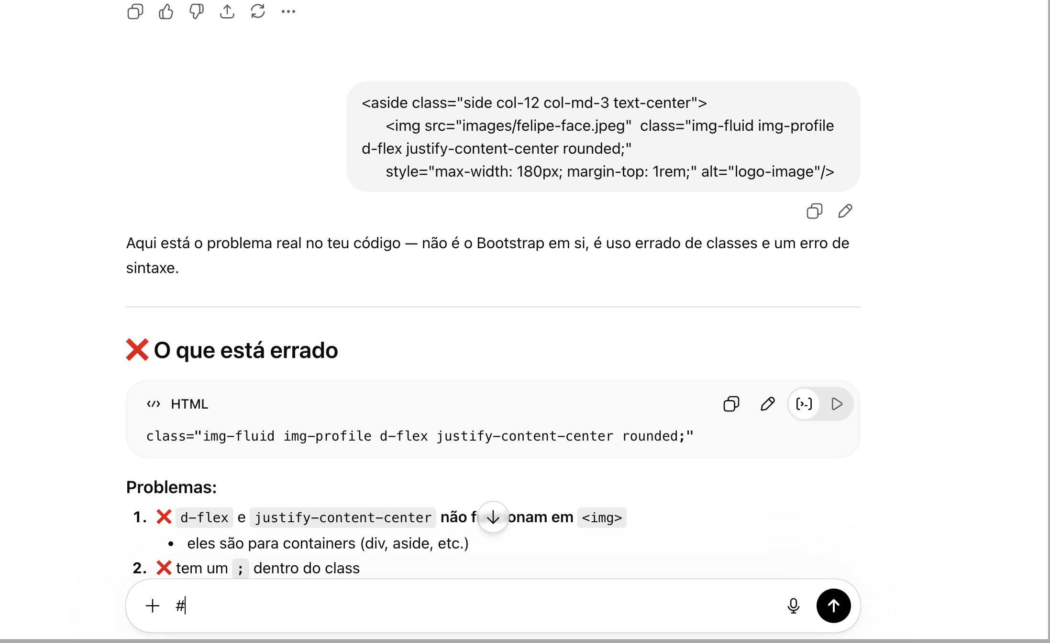

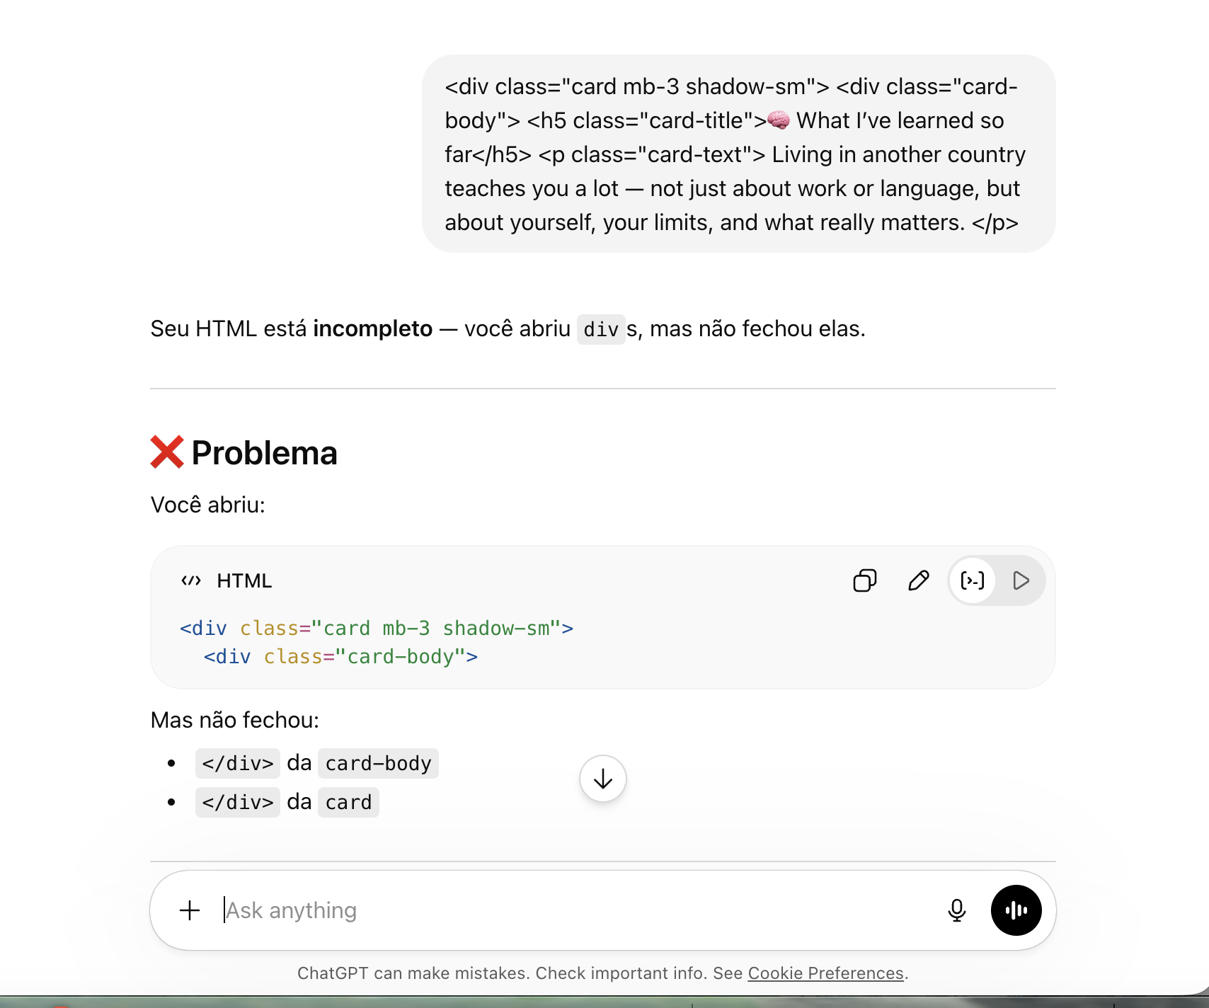

Developing the structure
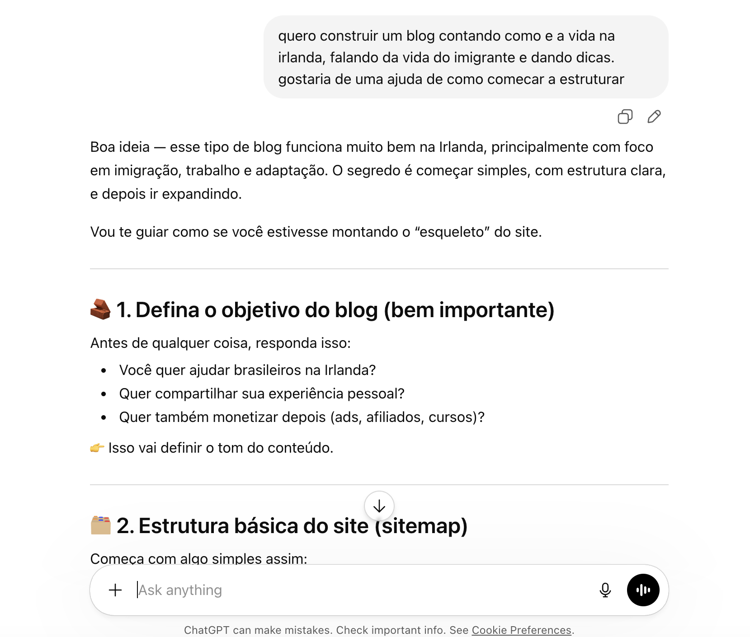

Building the logo
